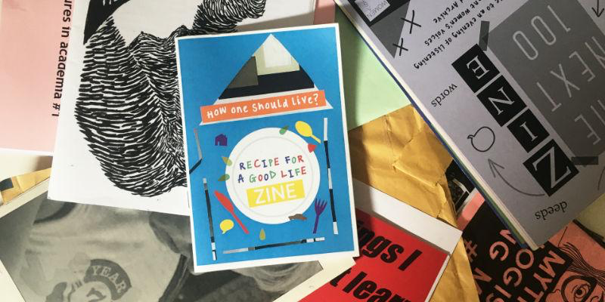

Contribute a zine page!

As part of a research project led by Dr Miro Griffiths, we’re inviting disabled people to make and contribute zine pages. On your zine pages, describe what you think an inclusive and accessible society would look and feel like.

What you’ll need

- A5 white piece of paper (this will be the size of your zine page)
- Scissors
- Glue
- Old magazines, newspapers, and anything else you can collage with!
- Pens
- Optional: stickers and or photos

Instructions

- Plan what your zine page will be about. Choose your pictures and think about any writing you might include.
- Organise your materials onto your A5 white page. Don’t worry about colour as the finished zine will be black and white.
- Once you’re happy with how it looks, glue it down.
- You might want to handwrite or draw on top next.
- You can use more than one page if you want to.
- Once you’re finished with your zine, scan it into the computer or take a high-quality photo of it on a neutral background.
- Fill out the zine form to tell us how you would like to be credited.
- Email your photo and zine form to Miro (m.griffiths1@leeds.ac.uk).

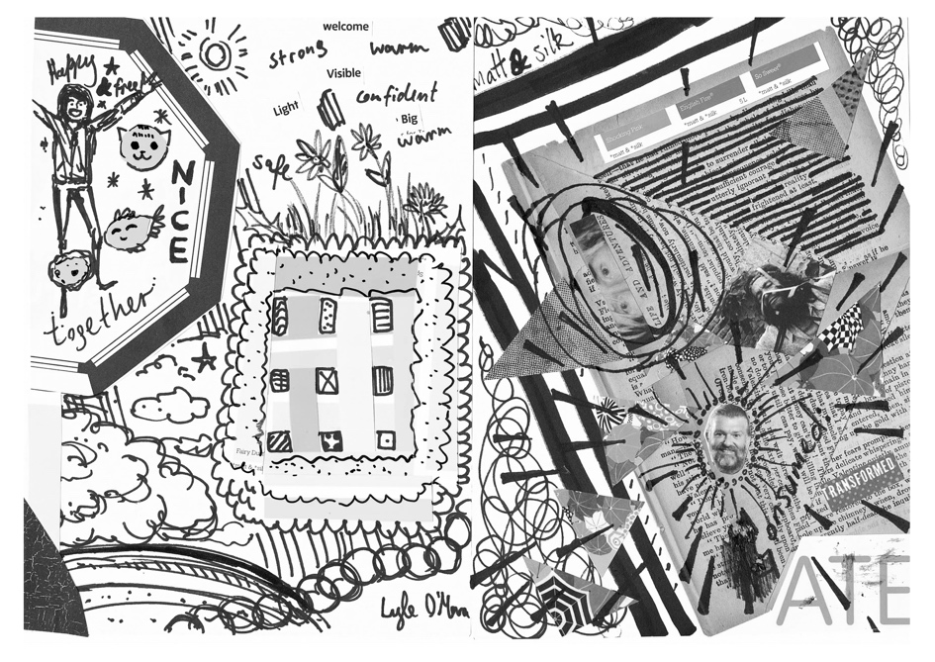
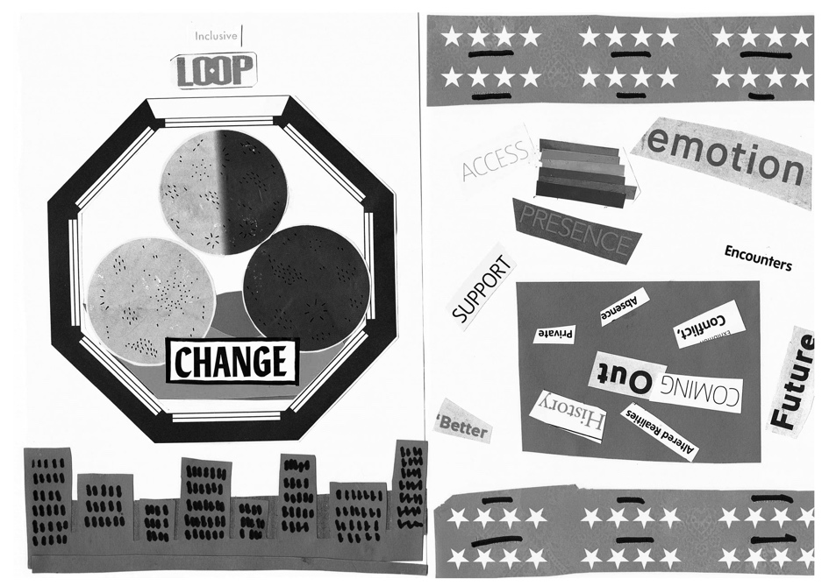

Tips and inspiration!

- Your zine page will be black and white – so don’t worry about colour, think about pictures, contrast, and pattern. See pictures above!
- Try cutting letters out of magazines or newspapers to spell words – this can look really fun and graphic.
- You can include your own handwriting and drawings.
- You can try drawing on top of pictures cut from magazines or newspapers to make them your own.

The following questions may help you when developing your zine page:
- What does accessibility and inclusion mean to you?
- What are the best and worst examples of accessibility and inclusion that you have experienced?
- What needs to happen to build an accessible and inclusive society?

Frequently Asked Questions

What is a zine?
A zine is a type of non-profit handmade magazine.

Who will see my zine page? Where will it go?
Your zine page will be included in the Future Laboratories zine as part of a research project by Miro Griffiths. The zine will be sent to disabled people’s organisations, policymakers, politicians, and anybody who wants to receive the zine. It will be digitised and kept online.

Why should I contribute?
Your ideas matter. This is an opportunity to inform people about what young disabled people think is important in an accessible and inclusive society.

How will I be credited?
This is up to you! You will need to fill out a very short form to tell us whether you would like your whole name, first name, a fake name or to remain anonymous.

If I have questions, can I talk to someone?
Yes! You can email Miro (m.griffiths1@leeds.ac.uk) and arrange a chat.
Can I find out more information about this research project?
Yes! You can visit the research project website at: https://disabilityactivism.leeds.ac.uk/.

