Making a Zine Page on Disability Activism in Europe

Information About the Project

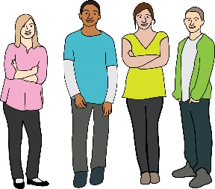
This zine is about young disabled people and inclusive societies. A zine is a handmade magazine.

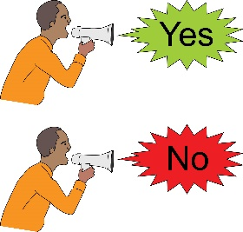
Would you like to take part in the making a zine page?

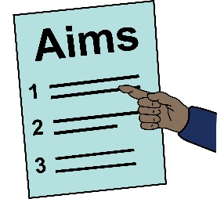
Before you decide, it is important that you understand what the zine is about.

It is important that you understand what taking part means for you. Please read this information sheet carefully.

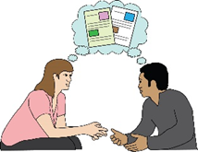
If you do not understand something, please ask someone close to you to explain.

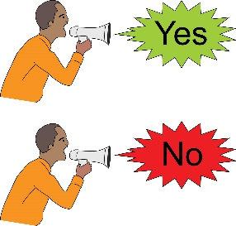
After you have finished reading this information sheet, you can decide if you want to take part.

If you want to take part you will need to read this sheet and the "agreeing to take part" sheet.

What is the project about?

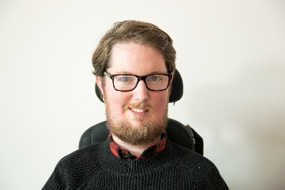
Miro Griffiths wants to find out what young disabled people think about disability activism across Europe.

Miro

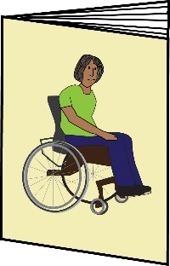
Disability activism can mean doing things like:

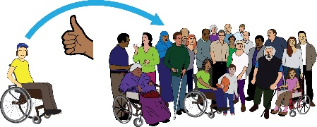
Campaigning for inclusion

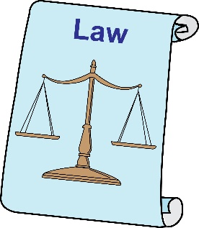
Protecting disabled people's rights

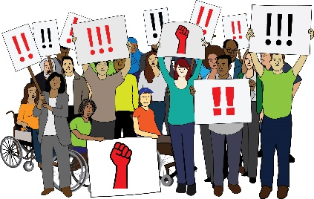

Protests

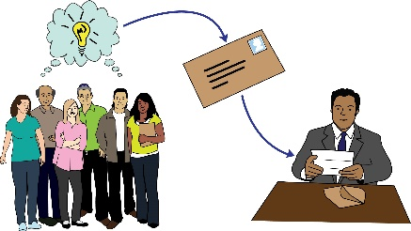
Contacting important people

Miro is doing this project because he is a researcher at the University of Leeds. Research means finding out about things and why they happen.

Miro wants to find out how young disabled people get involved in disability activism.

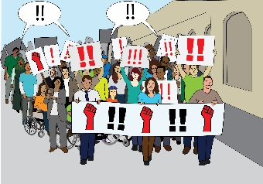
Miro thinks it is important that young disabled people take part in disability activism if they want to.

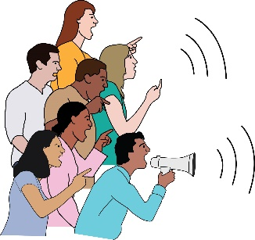
Miro hopes this project will show how young disabled people can take part in disability activism. Miro also hopes it will show where young disabled people are already being included in disability activism.

Why do you want me to take part?

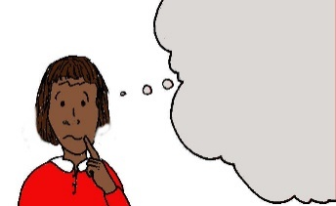
Miro wants to find out what young disabled people’s ideas about accessible and inclusive societies.

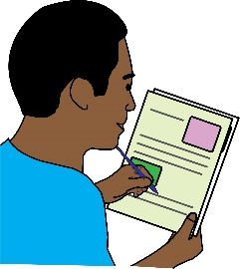
Miro wants young disabled people to make a page for a zine about accessible and inclusive societies.

To take part in making a zine page:

you will need to be 18 to 35 years old

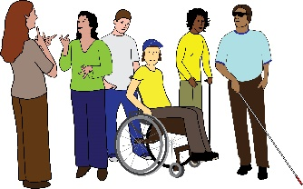
you will need to be a disabled person

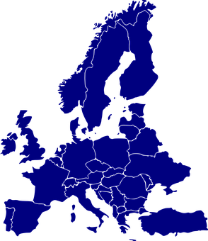

you will need to live in Europe

you will need to be interested in disability activism

Do I have to take part?
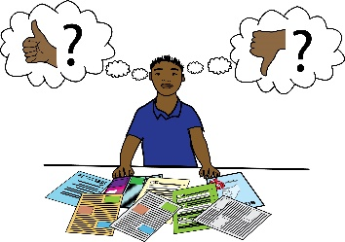
This is up to you. If you would like to take part you will need to read the "agreeing to take part" sheet.

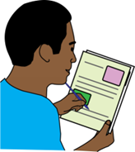
Then you can make a zine page using the instructions from this website: https://disabilityactivism.leeds.ac.uk/getting-involved-in-the-research-2/zine-disability-activism-in-europe/

You can stop taking part at any time. You don't have to tell Miro why if you don't want to.

What will happen to me if I take part?

You can make a zine page using the instructions from this website: https://disabilityactivism.leeds.ac.uk/getting-involved-in-the-research-2/zine-disability-activism-in-europe/

You can then send your zine page to Miro.

It will take about 45 minutes to make a zine page.

What will Miro ask me?

Miro will ask you to draw or write about what accessibility and inclusion means to you.

Miro will read through your zine page and learn from your ideas.
Miro

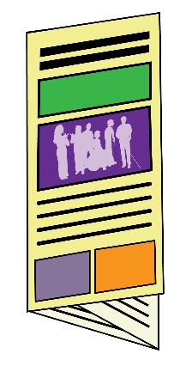

You will be able to keep a copy of your zine page and the completed zine. The completed zine will have pages from lots of disabled people.

You will have the option to give Miro your email address if you want to take part in more research about disability activism.

Will taking part be good or bad for me?

Taking part will take up some of your time.

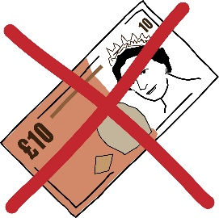

Miro cannot pay you for taking part.

Will you tell people what I say?

Miro will share the completed zine with anybody who wants to see it.

You can take part in the zine but hide your identity. This means you can still take part but people will not know you took part.

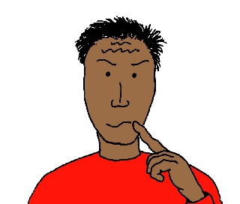
Miro will think about everybody's zine pages.

Miro will write down what he thinks is important and share this with people.

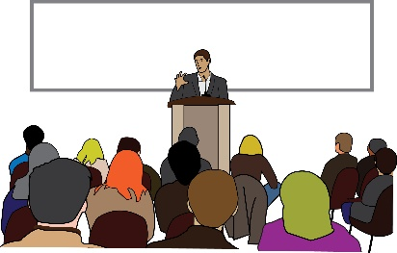
Miro will try and let other people know what he thinks about people's answers in the zine.

How do I find out more information or ask questions about the interview?

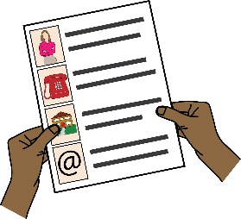
You can contact Miro:

by email – m.griffiths1@leeds.ac.uk

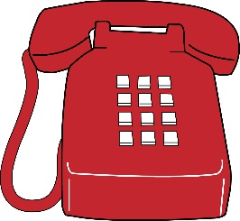

by phone – 0044 7835 413 238

If you are unhappy with Miro and you want to tell somebody why you are unhappy then please contact Angharad Beckett:

Angharad

by email – a.e.beckett@leeds.ac.uk

by phone – 0044 113 343 4409

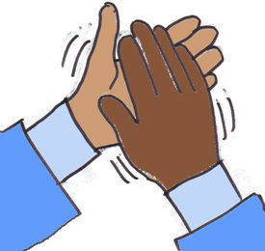
Thank you for thinking about taking part in the zine.

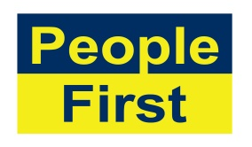
The images used in this document come from the People First (Self Advocacy) Picture Bank

And

Pixabay - https://pixabay.com/

