Making a Zine Page on Disability Activism in Europe

Agreeing to Take Part

Please read every question below and decide if your answer is yes or no.

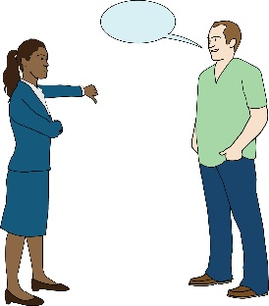
If you answer no to any of the questions then please do not take part in the zine.

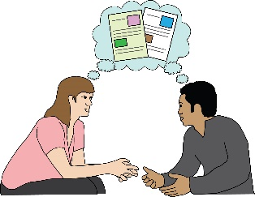
If you do not understand something, please ask someone close to you to explain.

 | Yes | No

Do you understand what the zine is about?

Have you been able to ask questions about the zine?

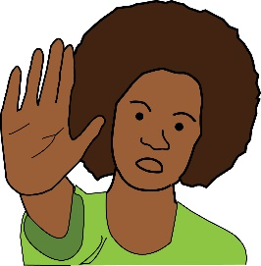

Do you understand that you can stop taking part if you change your mind?

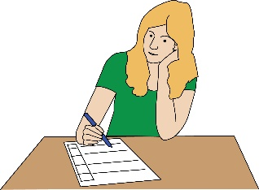

Do you understand that you don't have to answer any questions you don't want to?

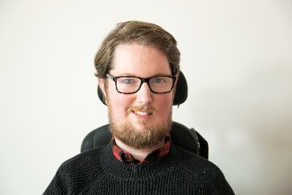
Do you understand that Miro Griffiths will decide how the completed zine will look?
Miro

Do you understand that anybody will be able to see the completed zine?

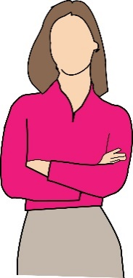
Do you understand that you can hide your identity when you take part in zine?

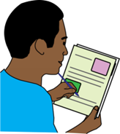

Do you want to take part in making a zine page?

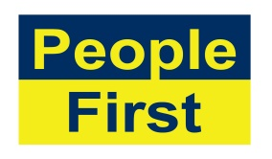
The images used in this document come from the People First (Self Advocacy) Picture Bank

