Interview on Disability Activism in Europe

Information About the Project

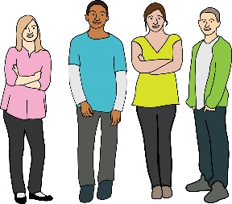
This interview is about young disabled people and activism.

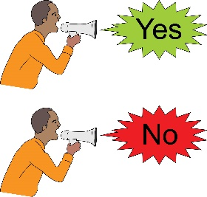
Would you like to take part in the interview?

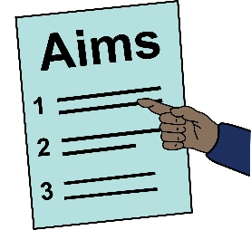
Before you decide, it is important that you understand what the interview is about.

It is important that you understand what taking part means for you. Please read this information sheet carefully.

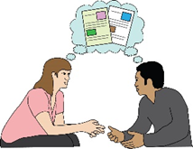
If you do not understand something, please ask someone close to you to explain.

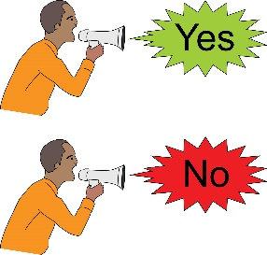
After you have finished reading this information sheet, you can decide if you want to take part.

If you want to take part you will need to read this sheet and the "agreeing to take part" sheet.

What is the project about?

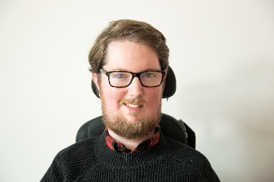
Miro Griffiths wants to find out what young disabled people think about disability activism across Europe.

Miro

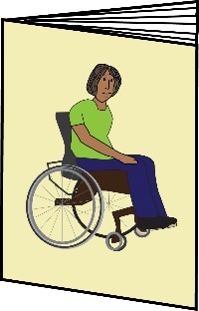
Disability activism can mean doing things like:

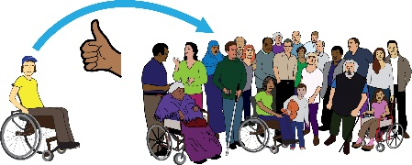
Campaigning for inclusion

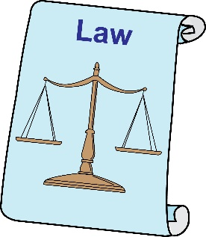
Protecting disabled people's rights

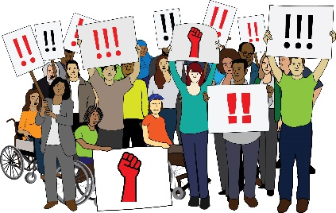

Protests

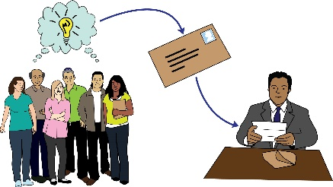
Contacting important people

Miro is doing this project because he is a researcher at the University of Leeds. Research means finding out about things and why they happen.

Miro wants to find out how young disabled people get involved in disability activism.

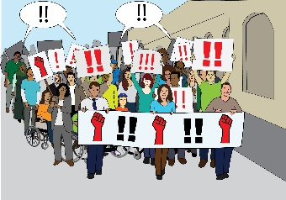
Miro thinks it is important that young disabled people take part in disability activism if they want to.

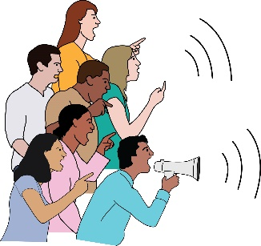
Miro hopes this project will show how young disabled people can take part in disability activism. Miro also hopes it will show where young disabled people are already being included in disability activism.

Why do you want me to take part?

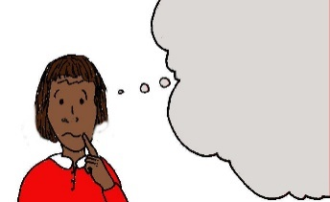
Miro wants to find out what young disabled people think about disability activism.

Miro wants young disabled people who are interested in disability activism to take part in the interview.

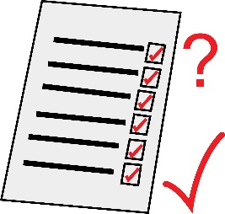
To take part in the interview:

you will need to be 18 to 35 years old

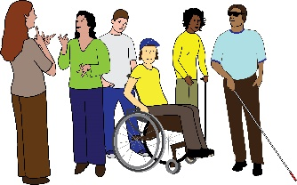
you will need to be a disabled person

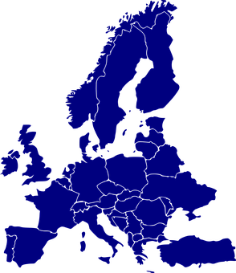

you will need to live in Europe

you will need to be interested in disability activism

Do I have to take part?
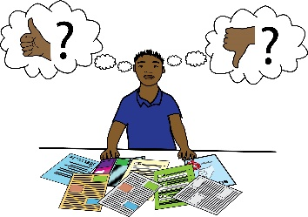
This is up to you. If you would like to take part you will need to read the "agreeing to take part" sheet.

Then Miro will interview you.

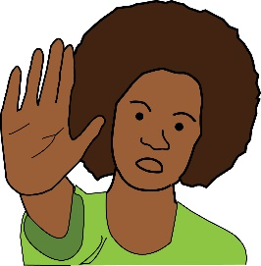
You can stop taking part at any time. You don't have to tell Miro why if you don't want to.

What will happen to me if I take part?

Miro will interview you.

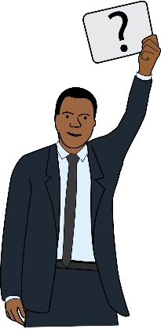
An interview is when somebody asks you questions and listens to your answers.

It will take about 30 minutes to complete the interview.

What will Miro ask me?

Miro will ask you about different ways of taking part in disability activism. Miro will ask you what you think about disability activism and if you have ever tried to take part in disability activism.

Miro will record the interview so he can listen to your answers again.
Miro

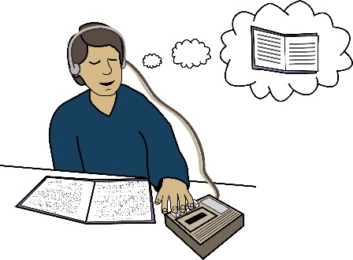
You will be able to keep a copy of your interview recording.

You will have the option to give Miro your email address if you want to take part in more research about disability activism.

Will taking part be good or bad for me?

Taking part will take up some of your time.

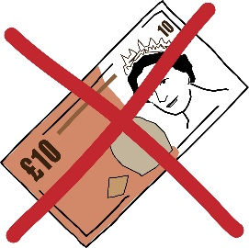

Miro cannot pay you for taking part.

Will you tell people what I say?

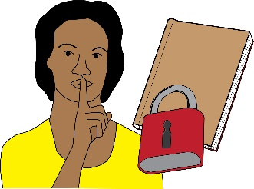
Miro will listen to all the answers from everybody who takes part in the interviews. Only Miro will listen to your answers.

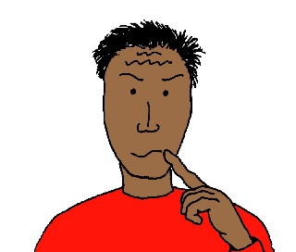
Miro will think about everybody's answers in the interview.

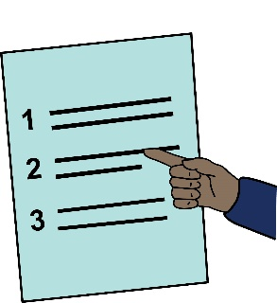
Miro will write down what he thinks is important and share this with people.

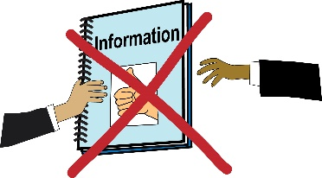
When Miro writes about the interviews he will not use your name or anything personal about you.

Miro will try and let other people know what he thinks about people's answers in the interviews.

How do I find out more information or ask questions about the interview?

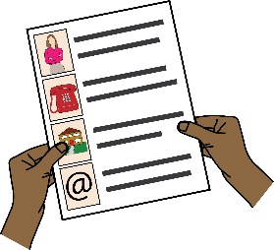
You can contact Miro:

by email – m.griffiths1@leeds.ac.uk

by phone – 0044 7835 413 238

If you are unhappy with Miro and you want to tell somebody why you are unhappy then please contact Angharad Beckett:

Angharad

by email – a.e.beckett@leeds.ac.uk

by phone – 0044 113 343 4409

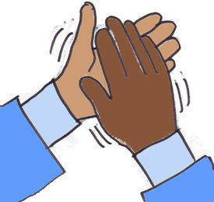
Thank you for thinking about taking part in the interview.

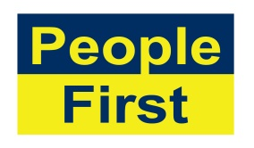
The images used in this document come from the People First (Self Advocacy) Picture Bank

And

Pixabay - https://pixabay.com/

