Interview on Disability Activism in Europe
Agreeing to Take Part

Please read every question below and decide if your answer is yes or no.

If you answer no to any of the questions then please do not take part in the interview.

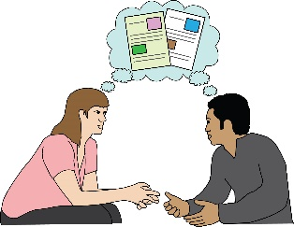
If you do not understand something, please ask someone close to you to explain.

 | Yes | No

Do you understand what the interview is about?

Have you been able to ask questions about it?

Do you understand that you can stop taking part if you change your mind?

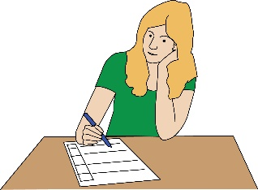

You understand that you don't have to answer any questions you don't want to?

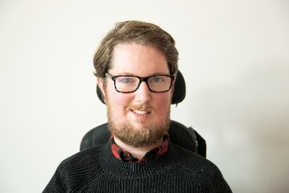
Do you understand that Miro Griffiths will be able to listen to your answers?
Miro

Do you want to take part in the interview?

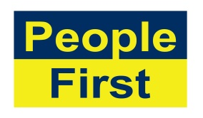
The images used in this document come from the People First (Self Advocacy) Picture Bank

