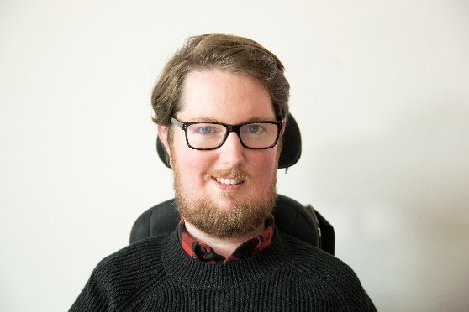

**My**

**One**

**Page**

**Profile**

**How to**

**support**

**me**

I am a power wheelchair user and require 24-hour personal assistance. I employ my own personal assistants.

I am unable to write notes and prefer information to be sent to me electronically.

**Miro Griffiths**

Occupation –

Research Fellow

**What people** **appreciate** **about me**

I like to listen to people's perspectives and ideas about issues that are important to them.

I want to try and change the way society is organised so that we can reduce unnecessary barriers that restrict our participation.

**What is**

**important**

**to me**

I am proud of my identity as a disabled person. My view of inclusion means that we should not change the individual but, instead, change the way society is organised. This means focusing on barriers within the environment, people's attitudes, and policies that can affect disabled people.

I work at the University of Leeds and carry out research with young disabled people. My research focuses on young disabled people's experiences of campaigning and activism.