Interview on Disability Activism in Europe

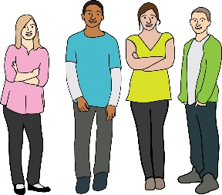
This interview is about young disabled people and activism.

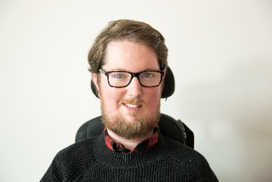
Miro Griffiths wants to find out what young disabled people think about disability activism across Europe.

Miro

To take part in the interview:

you will need to be 18 to 35 years old

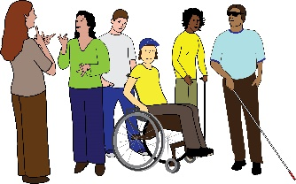
you will need to be a disabled person

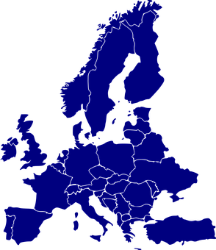

you will need to live in Europe

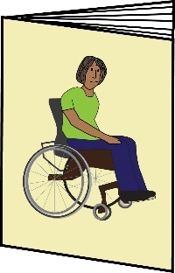
and you will need to be interested in disability activism

More information here: https://disabilityactivism.leeds.ac.uk/getting-involved-in-the-research-2/interview-disability-activism-in-europe/online-interview-participant-information-materials/

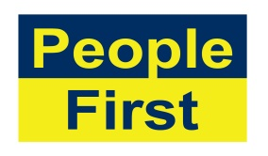
The images used in this document come from the People First (Self Advocacy) Picture Bank

And

Pixabay - https://pixabay.com/

