Survey on Disability Activism in Europe

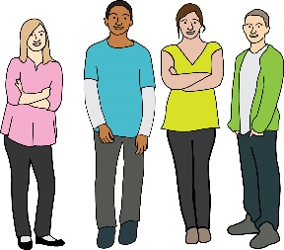
This survey is about young disabled people and disability activism.

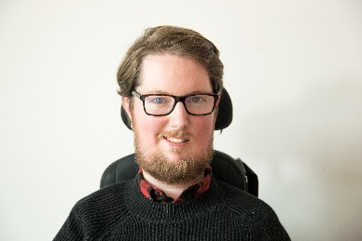
Miro Griffiths wants to find out what young disabled people think about disability activism across Europe.
Miro

If you want to take part you will need to read the “information about the project” sheet and the "agreeing to take part" sheet.

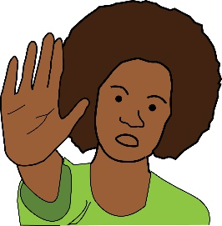
You can stop taking part at any time. You do not have to tell Miro why if you do not want to.

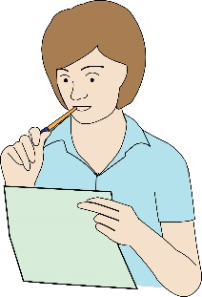

When you finish the survey please send Miro your answers. Miro's contact details are at the end of the survey.

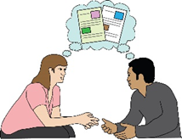
If you do not understand something, please ask someone close to you to explain.

Can you take part?

 | Yes | No
Do you understand and agree with the "agreeing to take part" sheet?
Is your age between 18 and 35 years old?

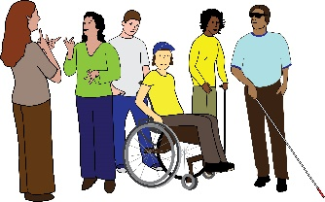
Are you a disabled person?

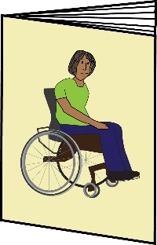
Are you interested in disability activism?

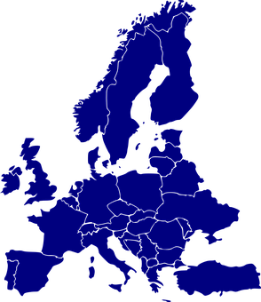
Do you live in Europe?

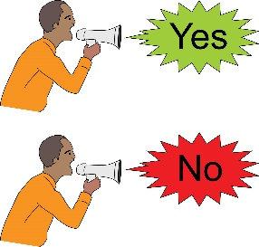
Only take part in the survey if you answered yes to every question above.

Questions About You

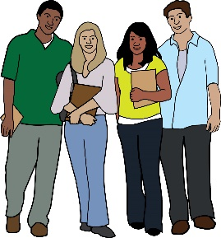
How old are you?

……………………………………………..

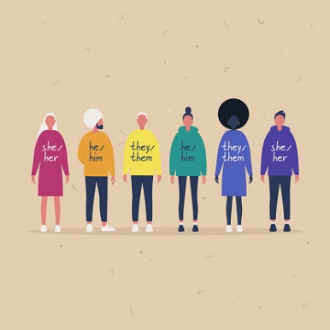
What is your gender?

…………………………………………………

Where are you a citizen of? If you have dual citizenship, please type both countries.

………………………………………………….

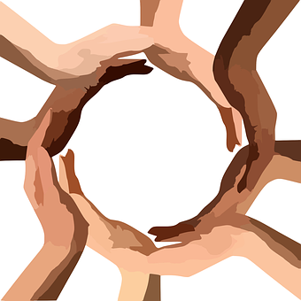
What is your ethnicity?

…………………………………………………

What country do you currently live in?

………………………………………………….

Which of the following best describes where you live? | Choose 1  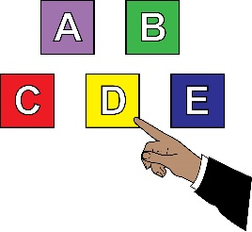
A city

A slightly rural location (a mixture of houses and fields and trees near me)

A rural location (not many other houses near me)

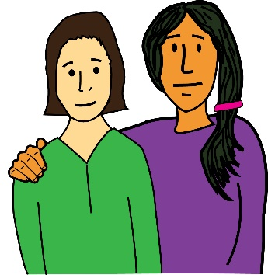  Do you receive enough support to be able to do the things you want to do with your life? | Choose 1

Yes

No

I do not need any support to be able to do the things I want to do with my life

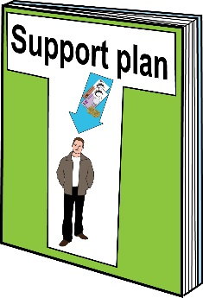  Who provides your support? | Choose as many as you want  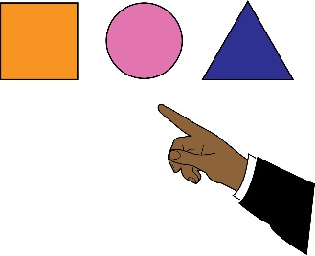
I do not need any support to be able to do the things I want to do with my life

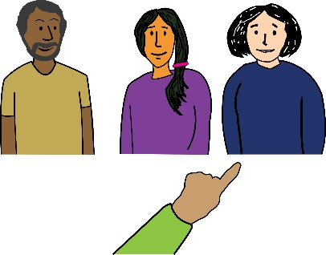
I choose who supports me and they are paid to support me
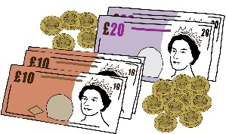
I do not choose who supports me and they are paid to support me

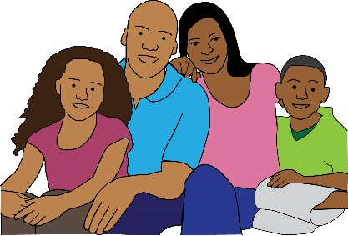
My family supports me
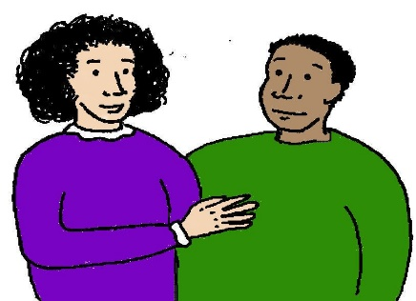
My friends support me

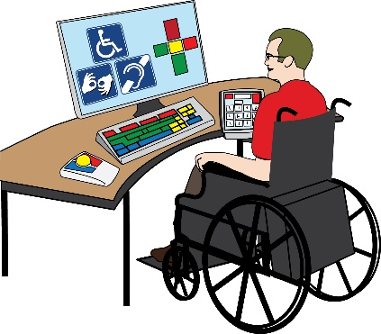
I use technology, like apps and computer programmes, to support me

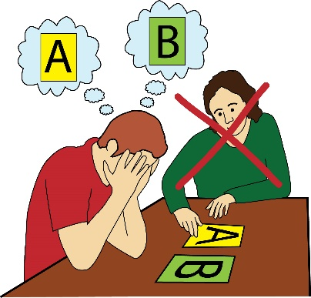
I need support but nobody supports me

Have you taken part in disability activism and, if so, for how long?  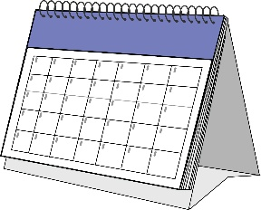 | Choose 1
I have not taken part in disability activism - Please go to Question 34
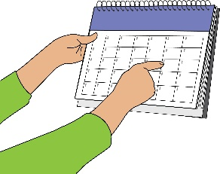
I have taken part for less than 1 year
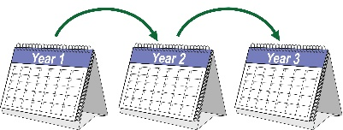
I have taken part for 1 to 3 years

I have taken part for 3 to 5 years
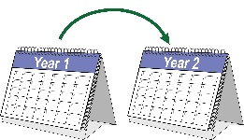
I have taken part for 5 to 10 years

I have taken part for more than 10 years

Questions About Disability Activism

What does it mean to be a disabled person?

……………………………………………………………………….

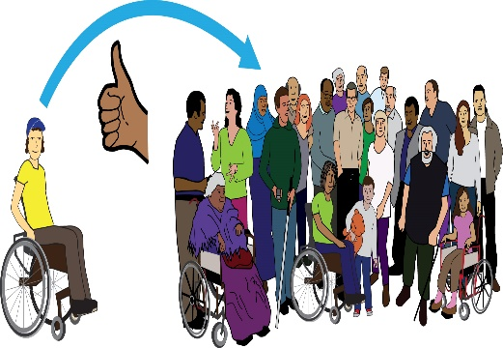  In Britain, young disabled people taking part in disability activism were asked what is important for improving disabled people's lives.  Their answers are below.  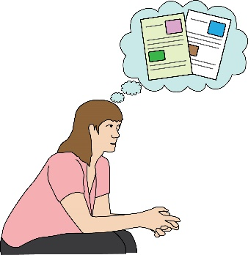  Which statements are important to you?  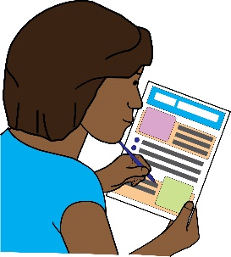  You can add more statements that you think are important but not included below. | 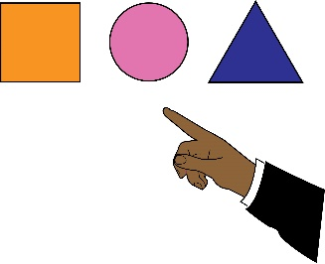  Choose as many as you want
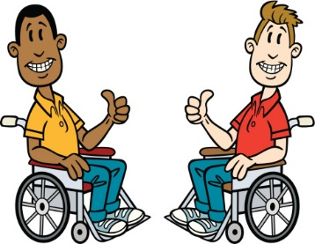
“Supporting disabled people to be proud of who they are (this is sometimes called disability pride)”

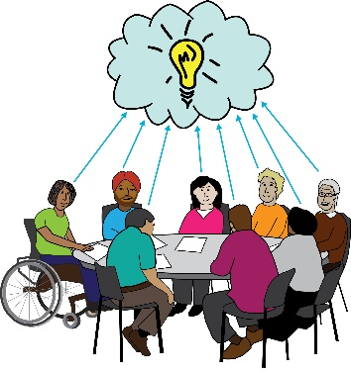
“Supporting disabled activists to learn about each other and work together”

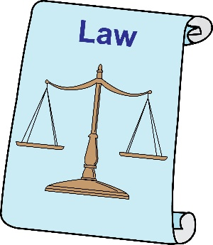
“Protecting disabled people's rights”

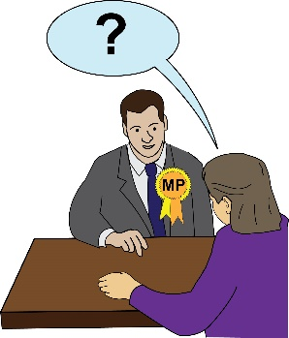
“Finding out how politicians do not help disabled people”

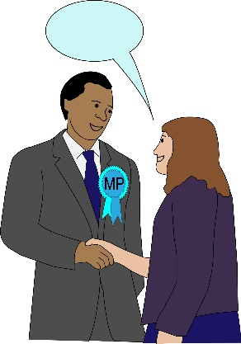
“Working with important people to improve disabled people's lives”

None of these statements are important

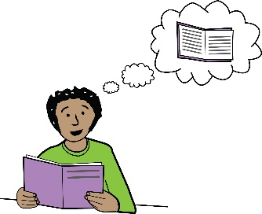
Can you think of any more ideas for improving disabled people's lives?

……………………………………………………………………….

How important is disability activism for feeling confident and in control of your life? | Choose 1
Not at all important
Slightly important
Important

Very important
It is the most important thing
I do not know

How important is disability activism for getting disabled people to work together? | 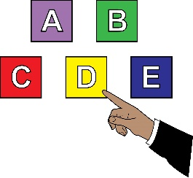  Choose 1
Not at all important
Slightly important
Important

Very important
It is the most important thing
I do not know

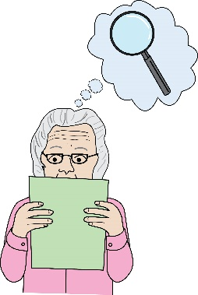  When you take part in disability activism what do you focus on? | 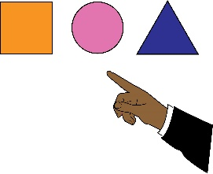  Choose as many as you want
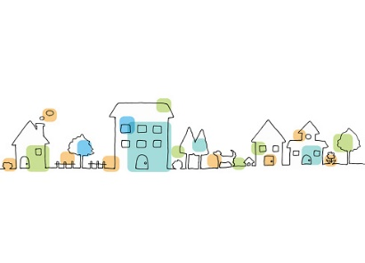
Local issues in the area where I live
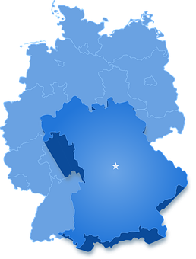
Regional issues in the area where I live

National issues in the country where I live
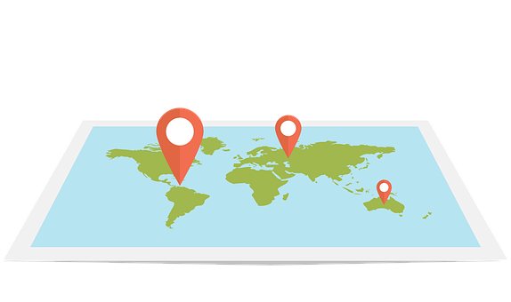
International issues in lots of countries
I focus on feeling confident and being in control of my life

Do any of the following barriers cause you problems when taking part in disability activism?  You can add more barriers that you think are important but not included below. | 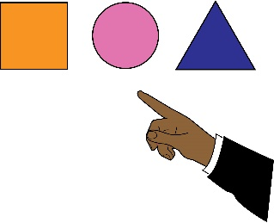  Choose as many as you want
I do not experience any barriers

I do not get enough support to take part in disability activism
I do not have enough money to take part in disability activism
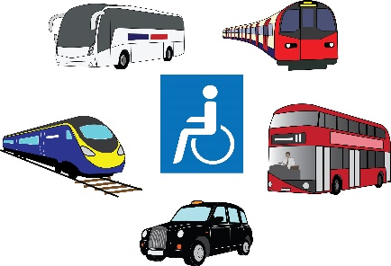
There is not enough accessible transport to take part in disability activism

It is difficult to access technology, like computers and the Internet, to take part in disability activism

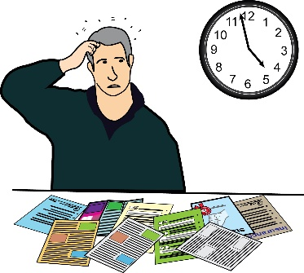
I do not have enough time to take part in disability activism

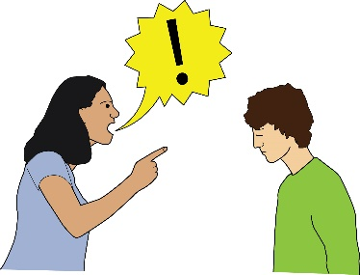
Important people in my life tell me not to take part in disability activism

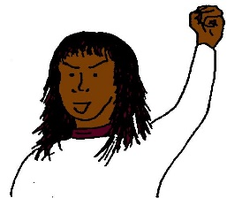
Other activists tell me not to take part in disability activism

I do not know enough about disability activism to take part

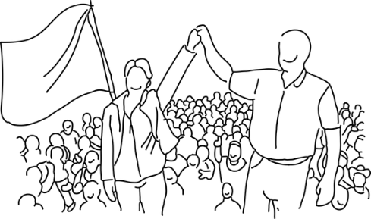
I do not know enough about how to campaign to take part in disability activism

Current disability activism campaigns do not interest me

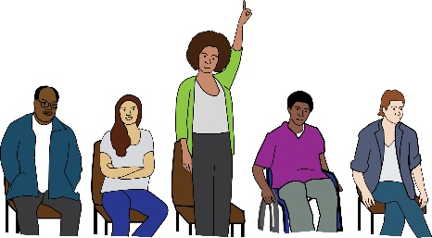
There are not enough opportunities to take part in disability activism

Can you think of any more barriers that cause you problems when taking part in disability activism?

……………………………………………………………………….

 | Yes | No | Do not know
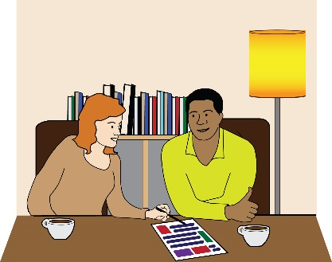
Do you feel supported to take part in disability activism?

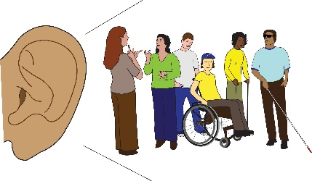
Do people listen and appreciate your ideas when you take part in disability activism?
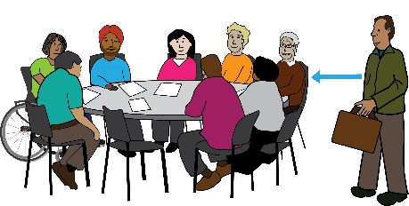
Do other activists involved in disability activism for a long time want to know about your ideas?

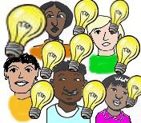
Are you able to focus on more than just things that are important to young people when you take part in disability activism?

How much do you know about the history of disability activism in the country where you live? | Choose 1
I do not know anything about the history of disability activism where I live
I know a little bit about the history of disability activism where I live
I know about the history of disability activism where I live

I know a lot about the history of disability activism where I live

I am not sure what my answer is

How much do you know about the history of disability activism across different countries in Europe? | Choose 1
I do not know anything about the history of disability activism across different countries in Europe

I know a little bit about the history of disability activism across different countries in Europe

I know about the history of disability activism across different countries in Europe

I know a lot about the history of disability activism across different countries in Europe

I am not sure what my answer is

 | Yes | No

Would you like to know more about the history of disability activism in the country where you live?

Do you know of any opportunities to learn about the history of disability activism in the country where you live?

 | Yes | No
Would you like to know more about the history of disability activism across different countries in Europe?

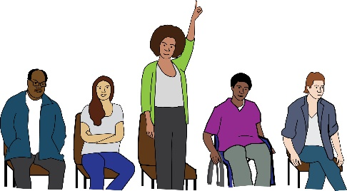
Do you know of any opportunities to learn about the history of disability activism across different countries in Europe?

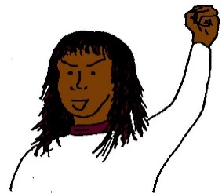  Do other activists expect you to know about the history of disability activism in the country where you live? | Choose 1
I am not expected to know about the history of disability activism in the country where I live

I am expected to know a little about the history of disability activism in the country where I live

I am expected to know about the history of disability activism in the country where I live

Other activists think it is very important that I know about the history of disability activism in the country where I live

I am not sure what my answer is

Do other activists expect you to know about the history of disability activism across different countries in Europe? | Choose 1
I am not expected to know about the history of disability activism across different countries in Europe

I am expected to know a little about the history of disability activism across different countries in Europe

I am expected to know about the history of disability activism across different countries in Europe

Other activists think it is very important that I know about the history of disability activism across different countries in Europe

I am not sure what my answer is

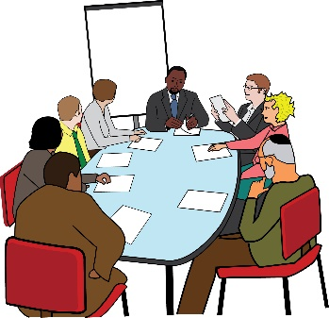  Imagine you are at an event with other young disabled people.  You are talking about what disability activism should focus on.  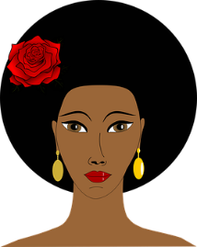  A disabled activist called Aiko says  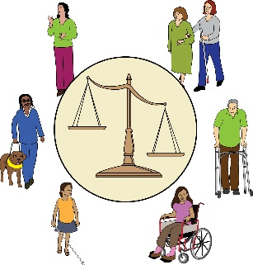  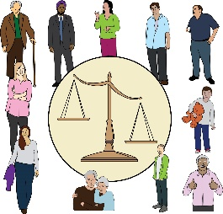  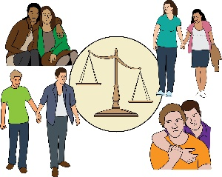  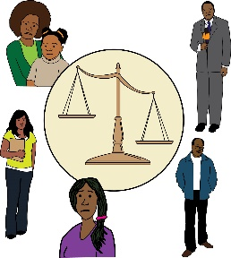  "disability activism should focus on the different ways we are discriminated. It is important to think about how disabled people can also experience discrimination because of gender, ethnicity, age, sexuality."  A disabled activist called Zenon says  "disability activism should focus only on disabled people being discriminated because of disability. It is important because disability is the most important thing."  Who do you agree with? | Choose 1
Aiko

Zenon

I do not agree with Aiko or Zenon

Can you think of any reasons why you do not agree with Aiko or Zenon?

………………………………………………….

I do not know who I agree with

In Britain, young disabled people taking part in disability activism were asked what needs to happen to improve opportunities for young people to take in disability activism.  Their answers are below.  Which statements are important to you?  You can add more statements that you think are important but not included below. | 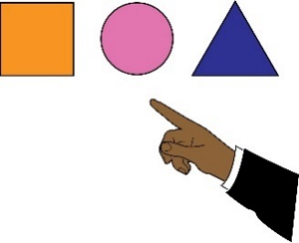  Choose as many as you want
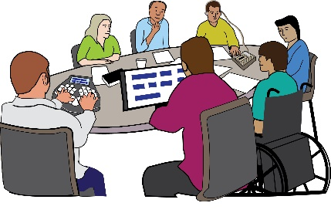
“Safe and accessible places to talk about improving disabled people's lives”
“Opportunities to focus on more than just things that are important to young people”

“Free and accessible information on the history of disability activism”

“Free and accessible information on important things happening within disability activism”

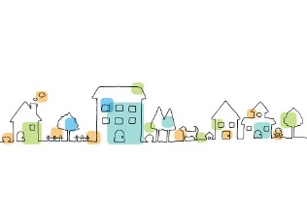
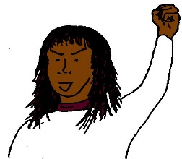
“Knowing about disabled activists and campaigners who live close to me”

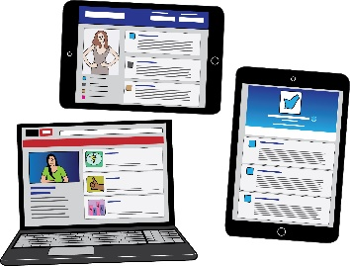
“Using social media to help more people know about disability activism”

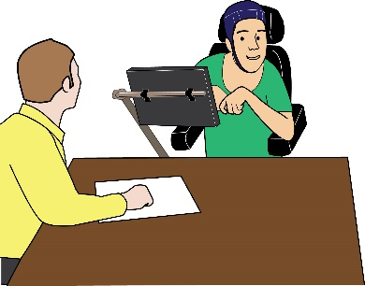
“Making sure disabled people who need a lot of support to take part in disability activism are supported to take part”

“Other activists involved in disability activism for a long time support young disabled activists”

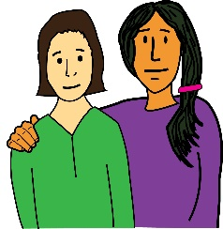
“Making sure young disabled people have access to support to take part in disability activism”

None of these statements are important

Can you think of any more ideas for improving opportunities for young disabled people to take part in disability activism?

……………………………………………………………………….

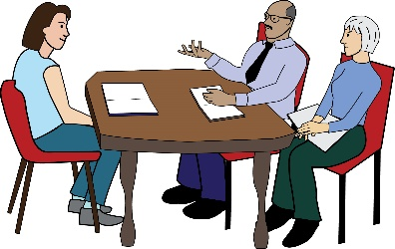  When you got involved in disability activism, who did you speak to for advice and to learn more about disability activism?  You can add more people that you think are important but not included below. | Choose as many as you want
I have not spoken to anybody to get advice and learn more about disability activism

I have spoken to my family to get advice and learn more about disability activism

I have spoken to my friends to get advice and learn more about disability activism

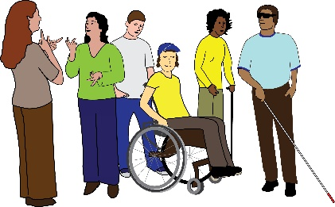
I have spoken to local campaigning groups run by disabled people. These groups focus on important things close to where I live

I have spoken to national campaigning groups run by disabled people. These groups focus on important things across the country I live in

I have spoken to international campaigning groups run by disabled people. These groups focus on important things in lots of countries

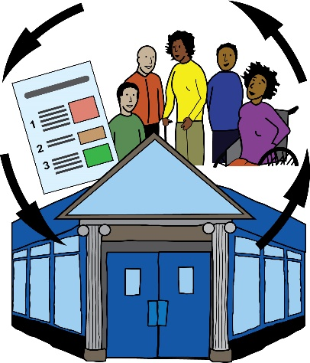

I have spoken to groups that support disabled people. Some of these groups are not run by disabled people

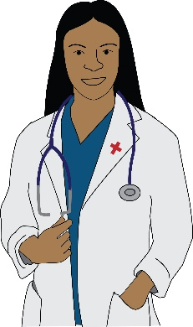
I have spoken to people who can decide how much support I get, like doctors and social workers. Sometimes they are called experts

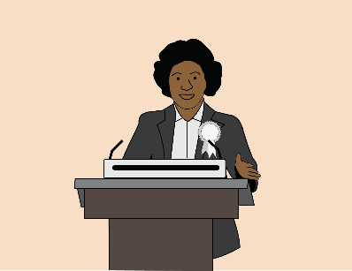
I have spoken to politicians to get advice and learn more about disability activism
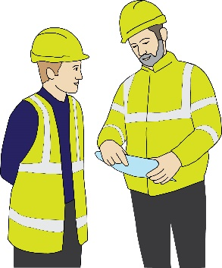
I have spoken to groups that support people in work. Sometimes these are called trade unions

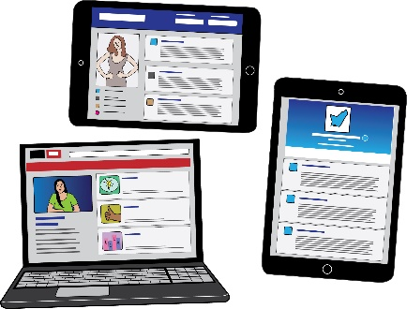
I have spoken to people on social media to get advice and learn more about disability activism

I have spoken to people who do research with disabled people to get advice and learn more about disability activism

Can you think of any more people who you speak to for advice and to learn more about disability activism?

……………………………………………………………………….

 | Yes | No | Do not know
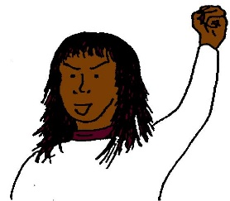
Do you think disabled activists across Europe are doing enough to support new people taking part in disability activism?
You can add comments about your answer below:

……………………………………………………………………….

The list below shows different activities disabled activists use to promote their ideas and make important demands.  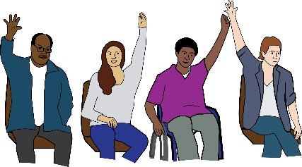  Which activities interest you?  You can add more activities that you are interested in but not included below. | Choose as many as you want
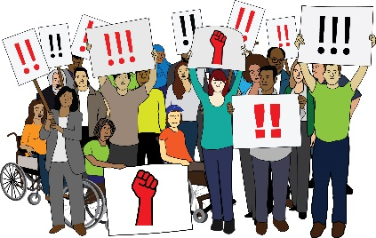
Protests

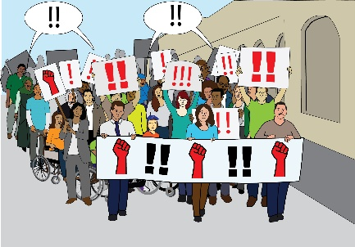
Big gatherings of people, sometimes called demonstrations

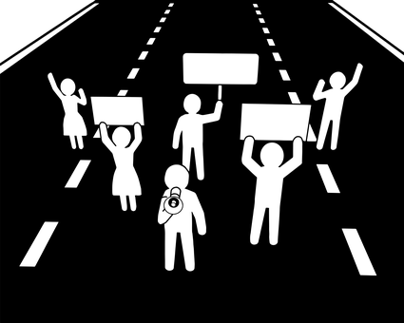
Other types of protest like blocking access to buildings and roads, sometimes called direct action

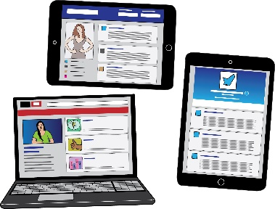
Using social media to share information and tell people important things

Writing articles

Giving out leaflets

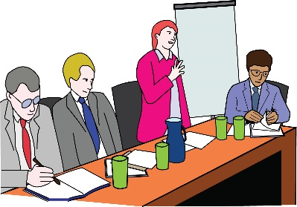
Taking part in debates

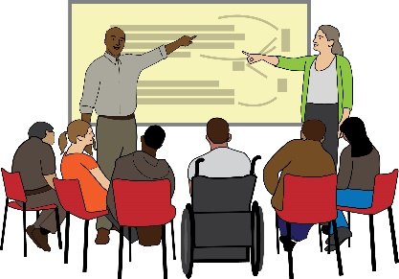
Taking part in conferences and workshops

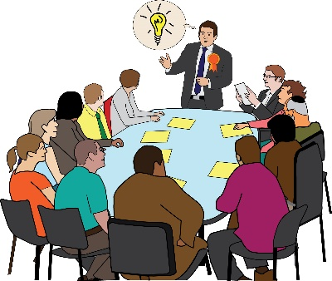
Talking to politicians and the government regularly in order to improve disabled people’s lives

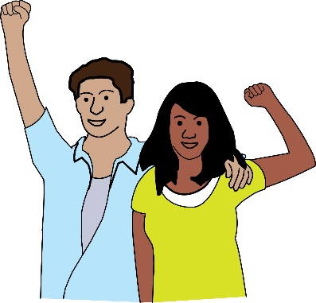
Finding people who are not disabled who can support disability activism

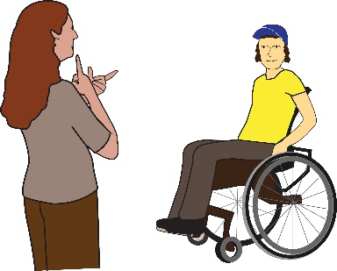
Helping other disabled activists to take part in disability activism

Can you think of any more activities that you are interested in to help promote disabled activist's ideas and demands?

……………………………………………………………………….

How much do you agree or disagree with the following statements about social media and disability activism?

"Social media helps to promote disabled activist's views and experiences"

Strongly agree | Slightly agree | Slightly disagree | Strongly disagree | Do not know
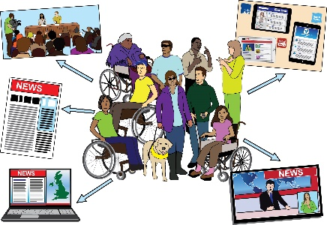
"Social media helps to make people aware about disability issues that they do not know a lot about"
Strongly agree | Slightly agree | Slightly disagree | Strongly disagree | Do not know
"Social media gives people opportunities to find and talk to other disabled activists"
Strongly agree | Slightly agree | Slightly disagree | Strongly disagree | Do not know
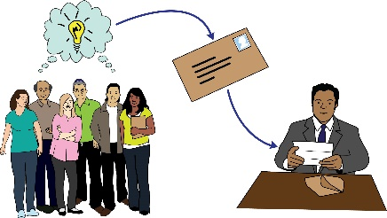
"Social media makes it easier to pressure and influence important people"

Strongly agree | Slightly agree | Slightly disagree | Strongly disagree | Do not know
"Social media can distract people from thinking about very important issues affecting disabled people"

Strongly agree | Slightly agree | Slightly disagree | Strongly disagree | Do not know
"Social media makes people think they are doing important things but they are not really doing important things”

Strongly agree | Slightly agree | Slightly disagree | Strongly disagree | Do not know

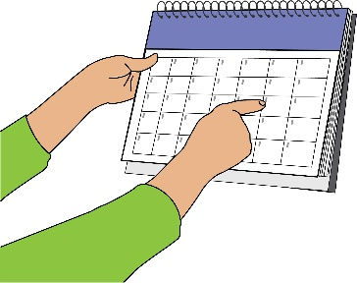  How often do you take part in disability activism? | Choose 1
I take part in disability activism every day
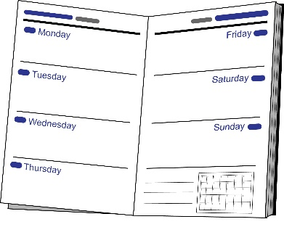

I take part in disability activism every week

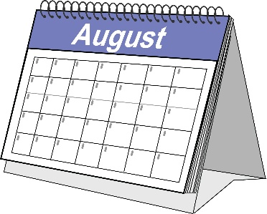
I take part in disability activism every month

I take part in disability activism every so often throughout the year

Do you agree or disagree with the following statements about disability activism? | Agree | Disagree | Do not know
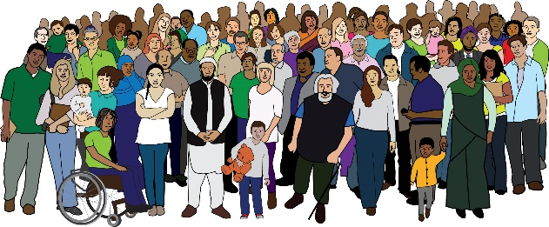
"Disabled activists should campaign for disabled people to be seen as normal and ordinary, just like everybody else"

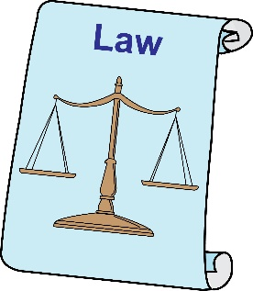
"It is important for disability activism to focus on disabled people's rights and the laws that protect disabled people"

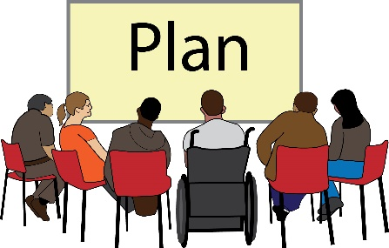
"It is important for disabled activists to have a solution before they campaign on an issue"

"Disabled activists need to know a lot about an issue before they start campaigning on that issue"

Imagine you are at an event with other young disabled people.  You are talking about how to improve disabled people's lives.  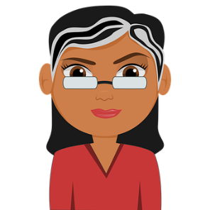  A disabled activist called Nova says  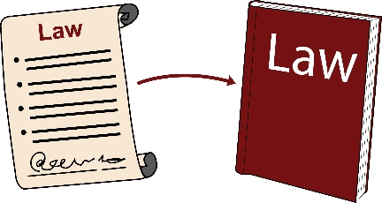  "the best way to improve disabled people's lives is to improve the laws that already exist. We can work towards inclusion by improving the policies that already exist."  A disabled activist called Vyri says  "the laws and policies that already exist cannot improve disabled people's lives. We need completely new ideas to make inclusion work."  Who do you agree with? | Choose 1

Nova

Vyri

I do not agree with Nova or Vyri

I do not know who I agree with
What comments would you make during this event?

……………………………………………………………………….

Imagine you are at an event with other young disabled people.  You are talking about how to support young disabled people to take part in disability activism.  A disabled activist called Alexis says  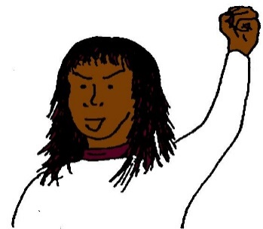  "a young disabled person is responsible for making sure they are included in disability activism. Other activists are not responsible for making sure a young disabled person takes part"  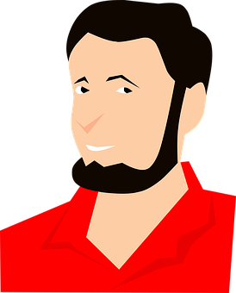  A disabled activist called Ivo says  "all activists are responsible for making sure young disabled people can take part in disability activism"  Who do you agree with? | Choose 1

Alexis

Ivo

I do not agree with Alexis or Ivo

Can you think of any reasons why you do not agree with Alexis or Ivo?

………………………………………………….

I do not know who I agree with

Please go to Question 40

What does it mean to be a disabled person?

……………………………………………………………………….

Have any of the following barriers stopped you from taking part in disability activism?  You can add more barriers that you think are important but not included below. | Choose as many as you want
I have not tried to take part in disability activism

I do not get enough support to take part in disability activism
I do not have enough money to take part in disability activism
There is not enough accessible transport to take part in disability activism

It is difficult to access technology, like computers and the Internet, to take part in disability activism

I do not have enough time to take part in disability activism

Important people in my life tell me not to take part in disability activism

Other activists tell me not to take part in disability activism

I do not know enough about disability activism to take part

I do not know enough about how to campaign to take part in disability activism

Current disability activism campaigns do not interest me

There are not enough opportunities to take part in disability activism

Can you think of any more barriers that cause you problems when trying to part in disability activism?

……………………………………………………………………….

Who would you speak to for advice and to learn more about disability activism?  You can add more people that you think are important but not included below. | Choose as many as you want
I would not speak to anybody to get advice and learn more about disability activism

I would speak to my family to get advice and learn more about disability activism

I would speak to my friends to get advice and learn more about disability activism

I would speak to local campaigning groups run by disabled people. These groups focus on important things close to where I live

I would speak to national campaigning groups run by disabled people. These groups focus on important things across the country I live in

I would speak to international campaigning groups run by disabled people. These groups focus on important things in lots of countries

I would speak to groups that support disabled people. Some of these groups are not run by disabled people

I would speak to people who can decide how much support I get, like doctors and social workers. Sometimes they are called experts

I would speak to politicians to get advice and learn more about disability activism
I would speak to groups that support people in work. Sometimes these are called trade unions

I would speak to people on social media to get advice and learn more about disability activism

I would speak to people who do research with disabled people to get advice and learn more about disability activism

Can you think of any more people who you would speak to for advice and to learn more about disability activism?

……………………………………………………………………….

Imagine you are at an event with other young disabled people.  You are talking about how to support young disabled people to take part in disability activism.  A disabled activist called Alexis says  "a young disabled person is responsible for making sure they are included in disability activism. Other activists are not responsible for making sure a young disabled person takes part"  A disabled activist called Ivo says  "all activists are responsible for making sure young disabled people can take part in disability activism"  Who do you agree with? | Choose 1

Alexis

Ivo

I do not agree with Alexis or Ivo

Can you think of any reasons why you do not agree with Alexis or Ivo?

………………………………………………….

I do not know who I agree with

In Britain, young disabled people taking part in disability activism were asked what is important for improving disabled people's lives.  Their answers are below.  Which statements are important to you?  You can add more statements that you think are important but not included below. | Choose as many as you want
“Supporting disabled people to be proud of who they are (this is sometimes called disability pride)”

“Supporting disabled activists to learn about each other and work together”

“Protecting disabled people's rights”

“Finding out how politicians do not help disabled people”

“Working with important people to improve disabled people's lives”

None of these statements are important

Can you think of any more ideas for improving disabled people's lives?

……………………………………………………………………….

Do you agree or disagree with the following statements about disability activism? | Agree | Disagree | Do not know
"Disabled activists should campaign for disabled people to be seen as normal and ordinary, just like everybody else"

"It is important for disability activism to focus on disabled people's rights and the laws that protect disabled people"

"It is important for disabled activists to have a solution before they campaign on an issue"

"Disabled activists need to know a lot about an issue before they start campaigning on that issue"

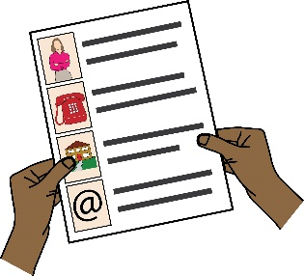
Would you like to be contacted so you can take part in more research about disability activism?

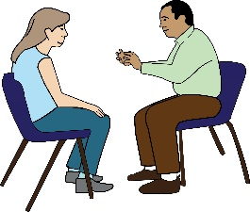

For example, you may be able to take part in interviews about disability activism.
If you would like to be contacted then give your email address below.

Your email address will only be read by Miro.

Miro

If you would like to be contacted to take part in more research about disability activism, please give your email address here:

……………………………………………………………………….

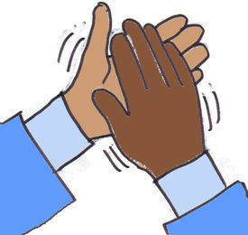
Thank you. You have now finished the survey.

Your answers will help to understand how young disabled people take part in disability activism.

Please remember to send your answers to Miro.
Miro

You can send your answers by email to m.griffiths1@leeds.ac.uk

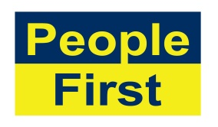
The images used in this document come from the People First (Self Advocacy) Picture Bank

And

Pixabay - https://pixabay.com/

